Assignment 1

Ratoath Community Centre

Nicholas Randles – B00058026



**Table of contents**

Abstract……………………………………………………………………………………………………………………………..…1

Design of application…………………………………………………………………………………………………….……..1

Introduction………………………………………………………………………………………………………………………….1

User research……………………………………………………………………………………………………………………….1

Wire framing………………………………………………………………………………………………………………………..1

Description of Application…………………………………………………………………………………………………….4

* Index page………………………………………………………………………………………………………………..4
* About Ratoath page………………………………………………………………………………………………….6
* About Centre page……………………………………………………………………………………………………7
* Activities page…………………………………………………………………………………………………………..8
* Venue theatre page………………………………………………………………………………………………..10
* Gallery page……………………………………………………………………………………………………………11
* Locate us page………………………………………………………………………………………………………..12
* Contact us page………………………………………………………………………………………………………14

Conclusion………………………………………………………………………………………………………………………….14

References………………………………………………………………………………………………………………………….15

**Abstract**

This document describes the steps involved in creating an interactive website for a community centre. The document focuses in on the planning and construction of the website for Ratoath Community Centre. The document shows all of the features that where implemented into the website and the specific reason they were implemented.

**Design of application**

**Introduction**

I live in Ratoath and as a member of the Ratoath Community I often use the Ratoath Community Centre website to see what is currently go on. I have been frustrated with the site for many reasons. The site is very basic and does not achieve its main goals. It is very hard to find what you are looking for because of its poor layout. Its design is very poor, its lack css and bad colour scheme makes it very unappealing. I got in contact with the head of the community centre and told him that I was making a website for the community centre and he agreed he would use the website. I told him I would create a website with a good colour scheme, achieves their main goals and is user friendly.

**User research**

The first thing I had to consider was who will be using the website. The obvious answer to this is the local members of the Ratoath community. They will be using the site to keep up to date with their local community centre. Since so many people of all different ages will be using the website I will have to do my best to please them all. I will be using a colour which is friendly to each sex. I will give the user the ability to enlarge text and images to facilitate old people and people with poor eye sight. I will make the site easy to manoeuvre so people who are not technically experienced can find what they are looking for.

**Wire Framing**

This is how I plan on laying out my index page.

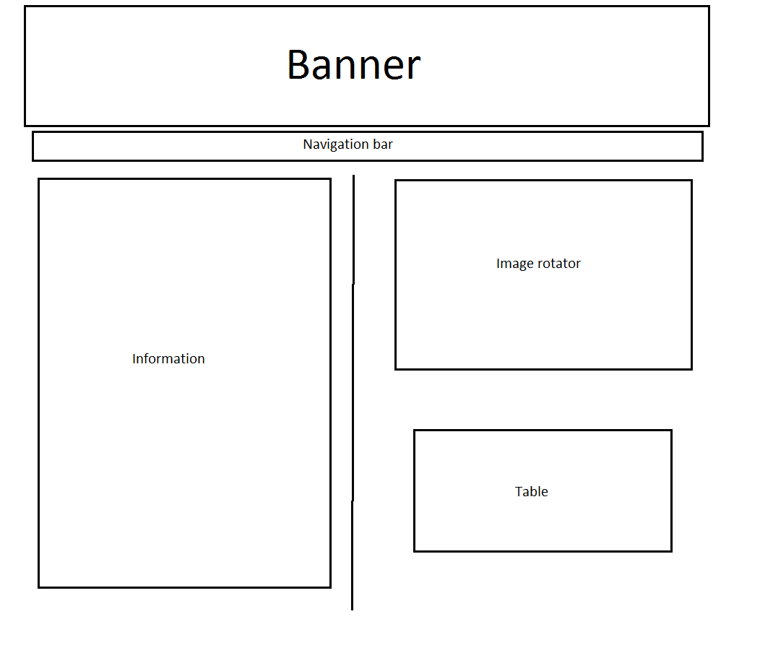

This is how I plan on laying out my map page.

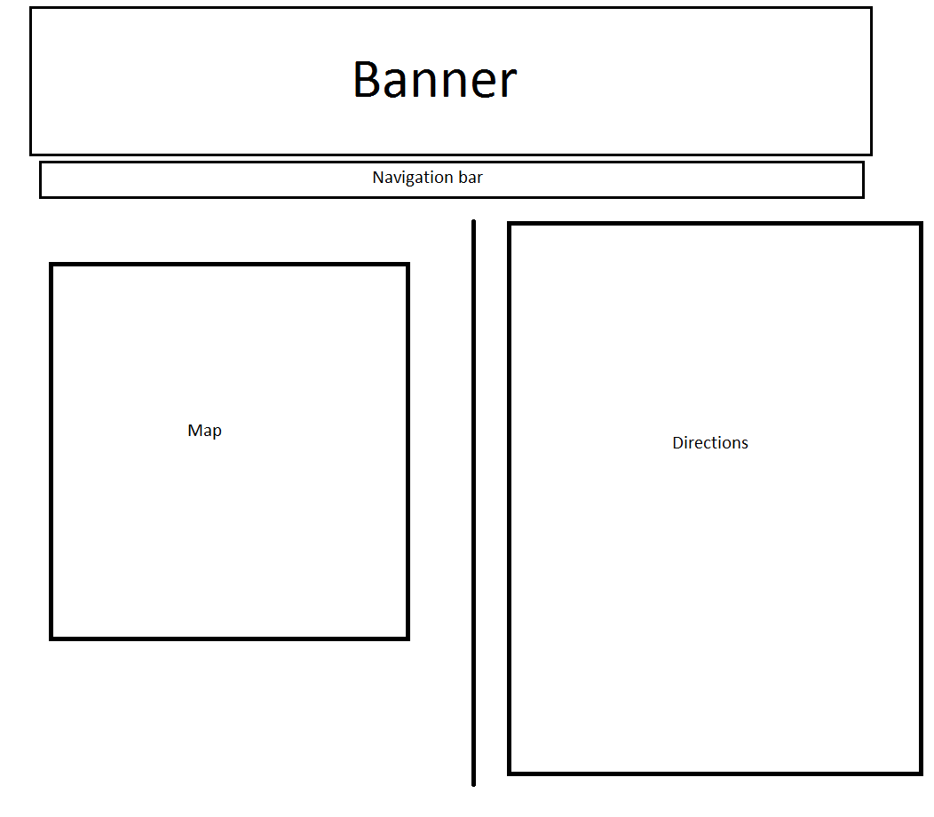

This is how I plan on laying out my gallery page.

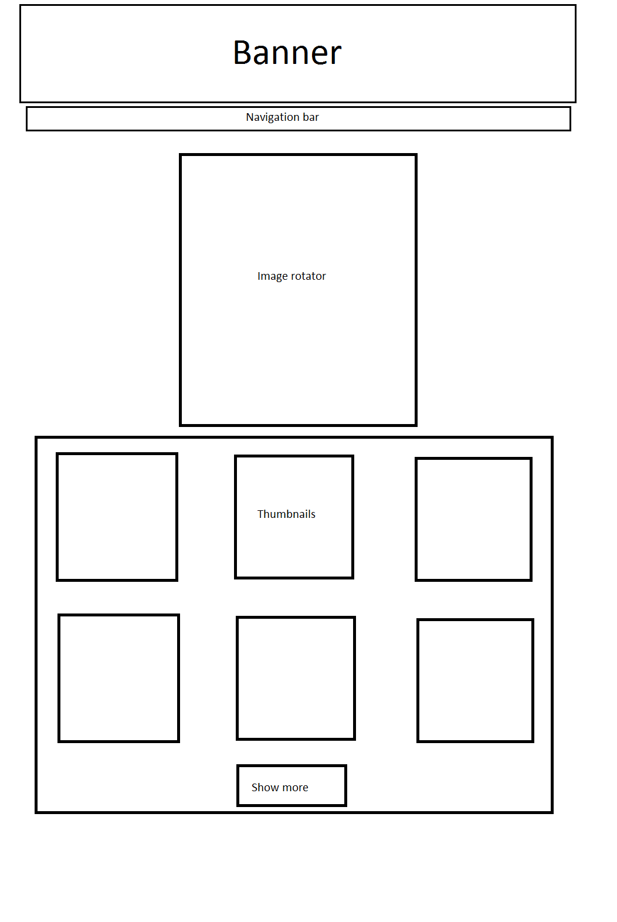

**Description of Application**

The complete site is very user friendly. It has a white and grey colour scheme. The website has a white and black banner which goes well with the white and grey colour scheme. The website has a jQuery navigation bar which drops down to show more options when the user hovers over one of the menu items. There is a footer on each page of the site which contains the telephone number, fax number and email address of the community centre. When the user clicks on the email icon an animation is performed which enlarges the icon and then word email is opened. Each page has its own unique features which I will explain below.

**Index page**

The index page has been split into two sides. On the left side, it shows the user information about the centre. The user has the ability to increase and decrease the text or set it back to default. The user can select read more which will show the user more info. The user can then press read less which will hide the extended text. On the right side is an image rotator which cycles through images of the centre. There is also a table on the right which has the odd and even rows in different colours. When the user hovers over a row, it will change colour, and when they hover out it will change back.

**Default index page**

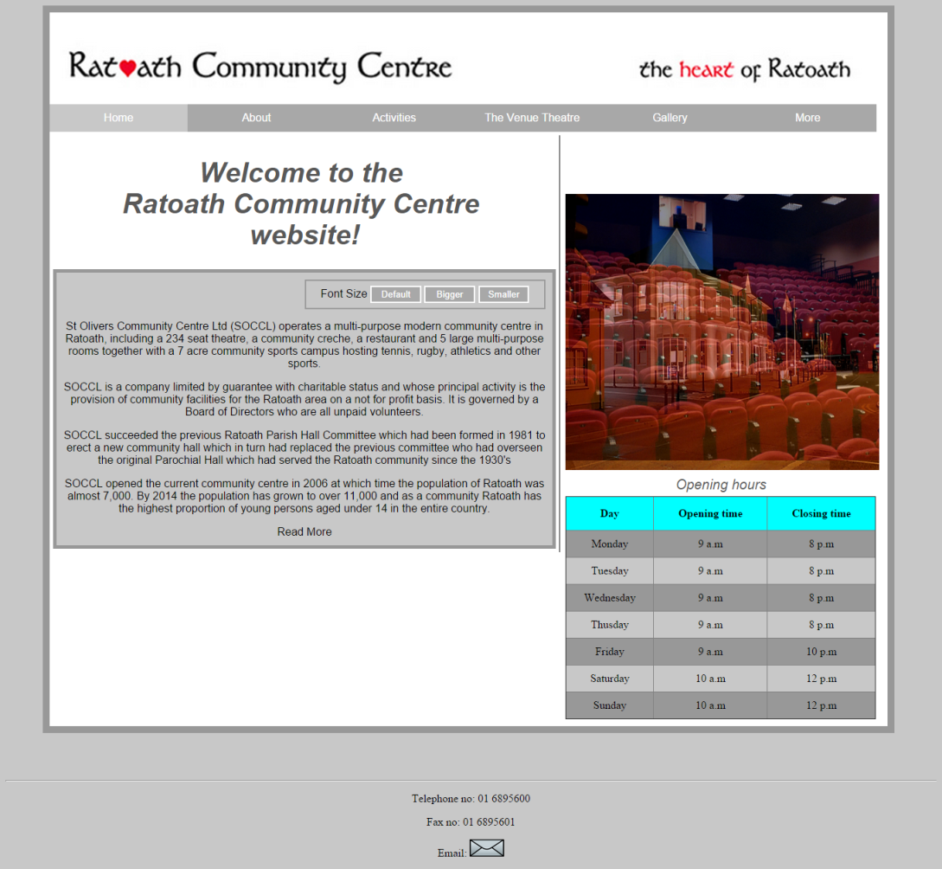

**Index page with text enlarged and read more selected**

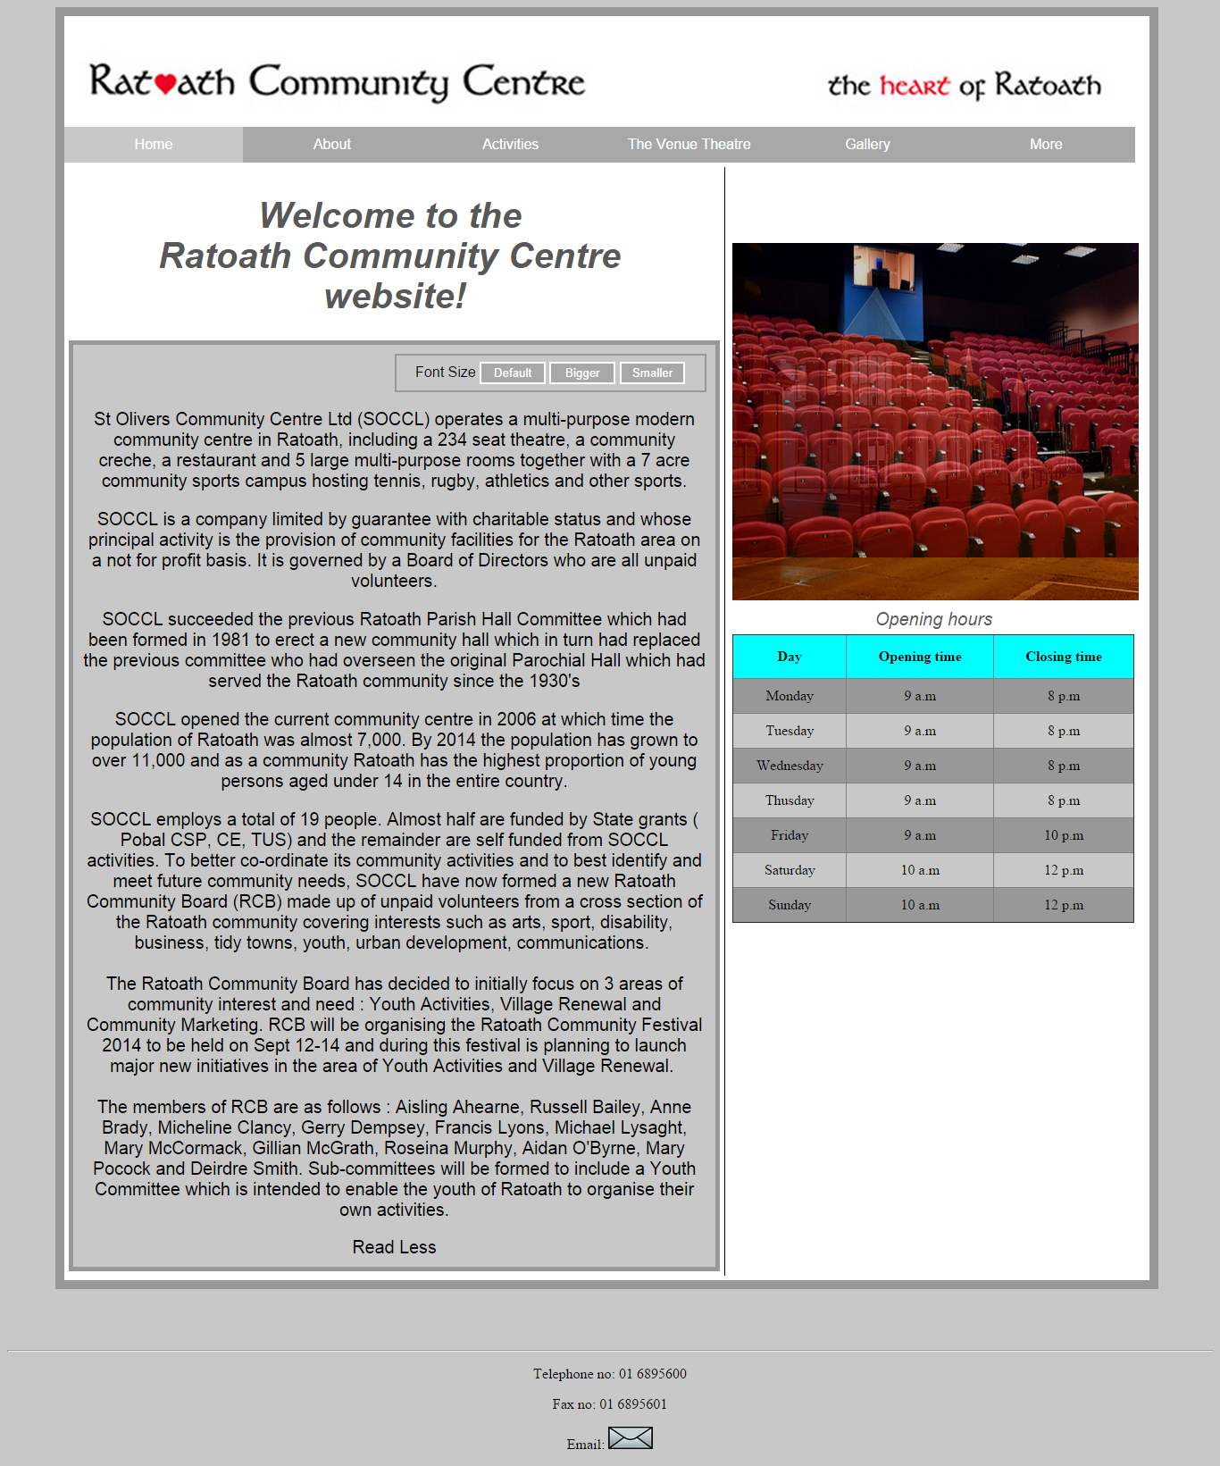

**About Ratoath page**

This page contains information about the Ratoath area. It contains and image at the bottom of the page which is enlarged when selected.

**Default about Ratoath page**

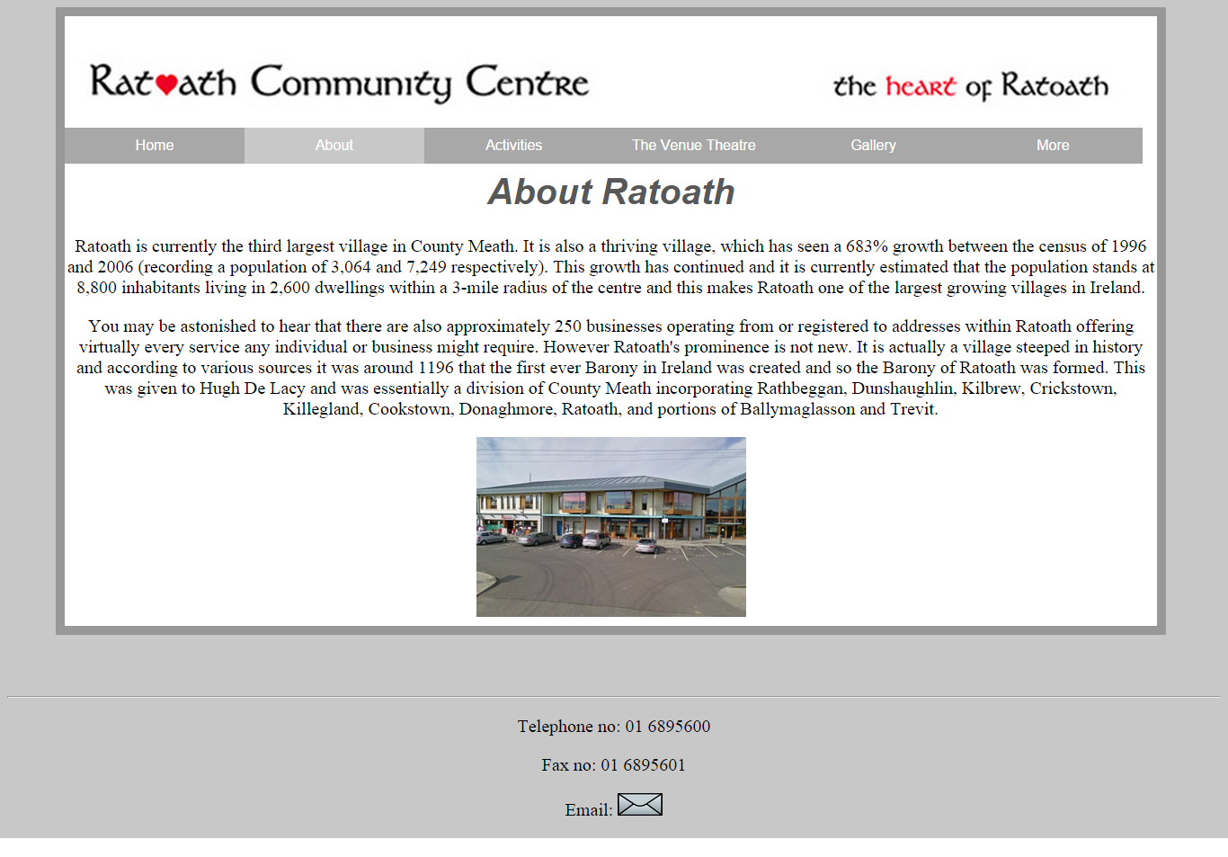

**About Ratoath page with image enlarged.**

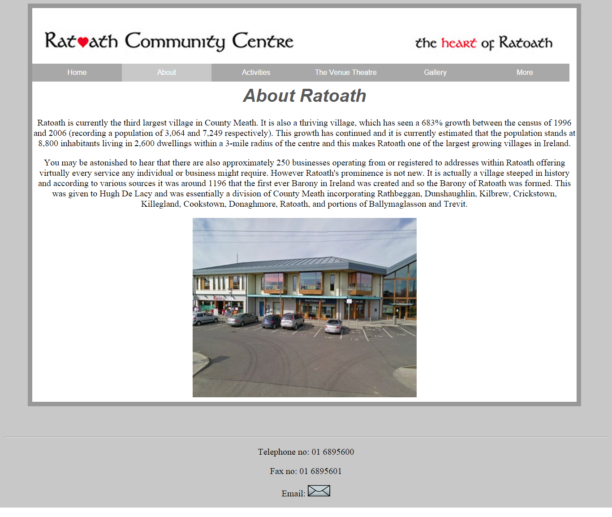

**About Ratoath Community Centre page**

This page contains information about the Ratoath Community Centre. It has three images on the bottoms of the page. When the images are pressed they fade out.

**Default about Ratoath Community Centre Page**

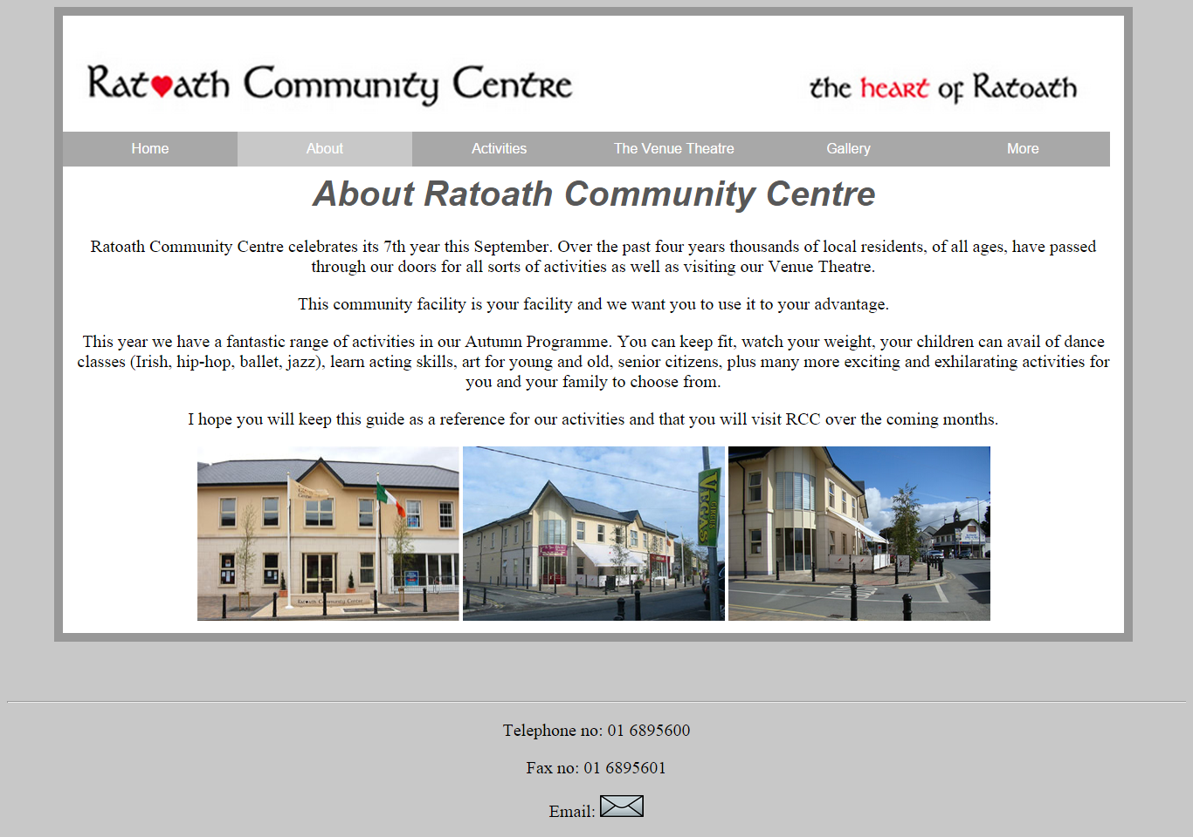

**About Ratoath Community Centre Page with one of the pictures faded out.**

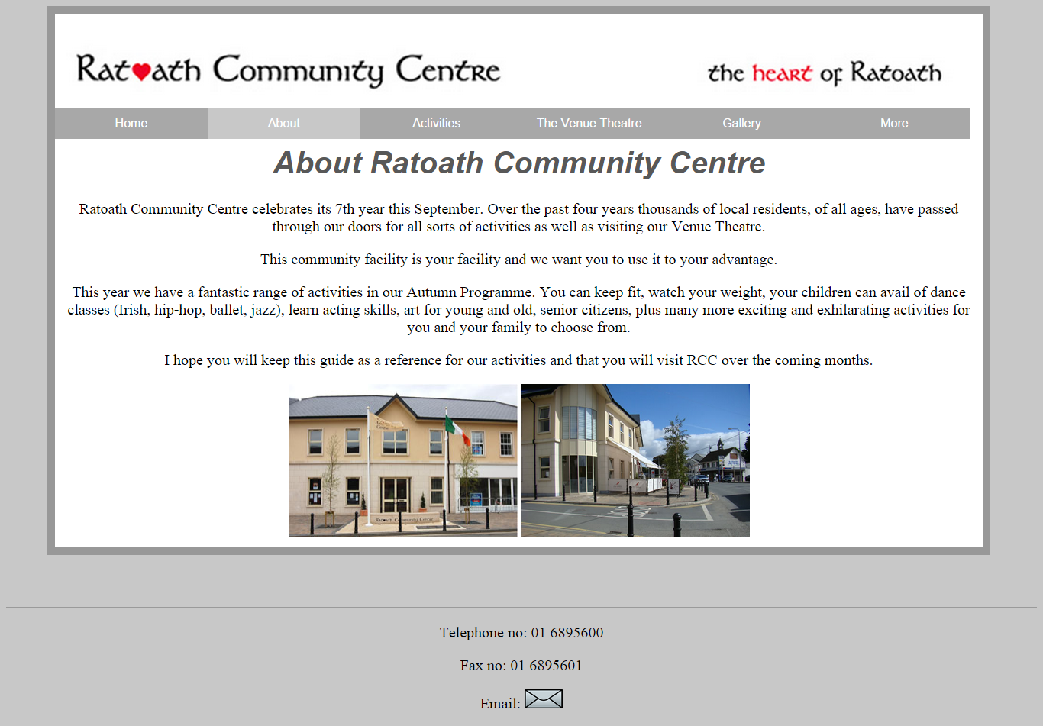

**Activities page**

This page contains information about all the activities that take place in the Community Centre. They are displayed with an accordion. I used the smoothness theme from jqueryui.com for the accordion widget. This is a very helpful jQuery feature as it helps display lots of data in a small space. When the images of the activities are pressed they increase in size.

**Default activities page**

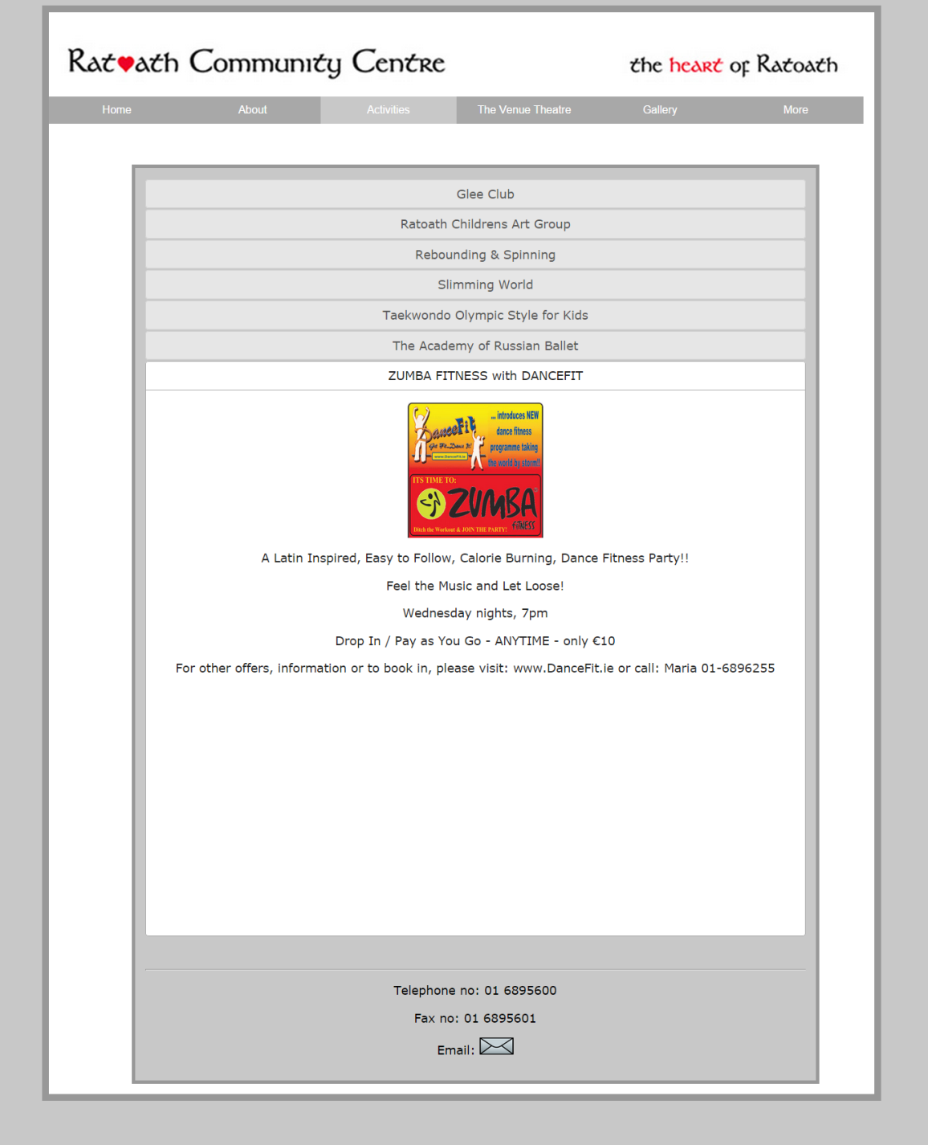

**Activities page with different activity selected and image enlarged**

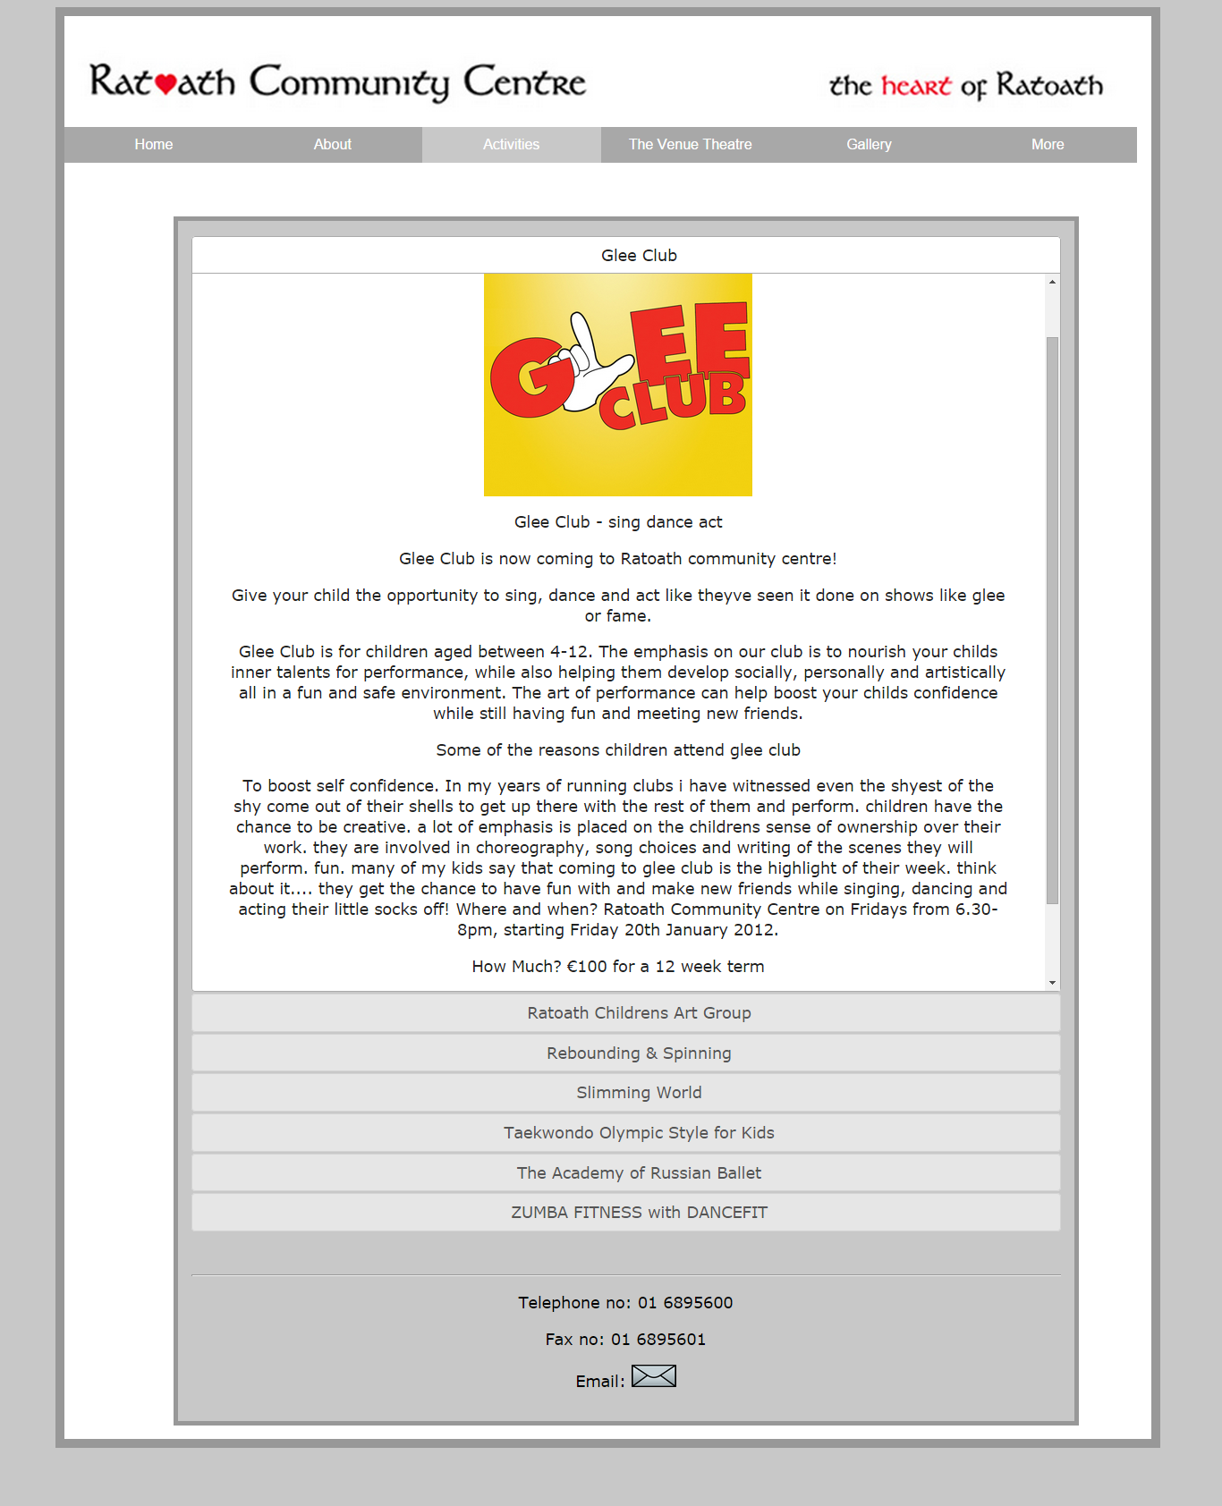

**The venue theatre page**

This page contains information about upcoming shows in the community centre’s venue theatre. I used Ajax and json on this page to avoid reloading the whole page each time the user selects a different show.

**Default venue theatre page**

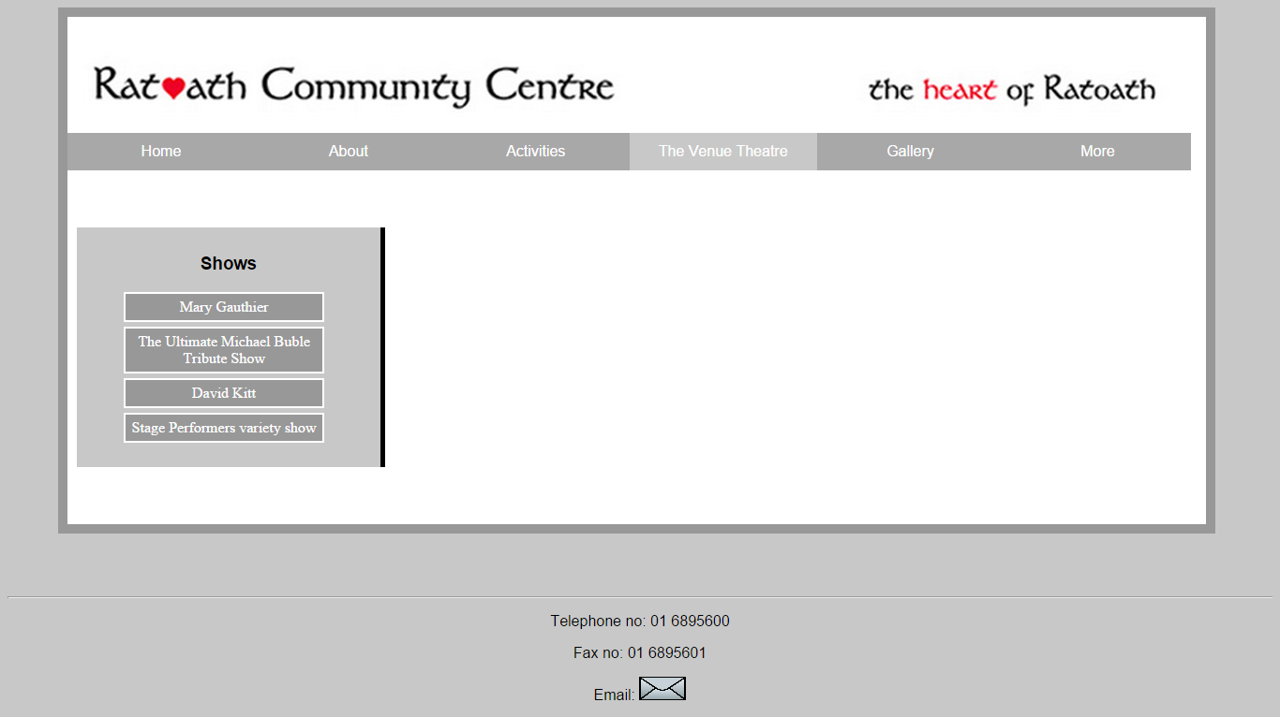

**Venue theatre page with a show selected**

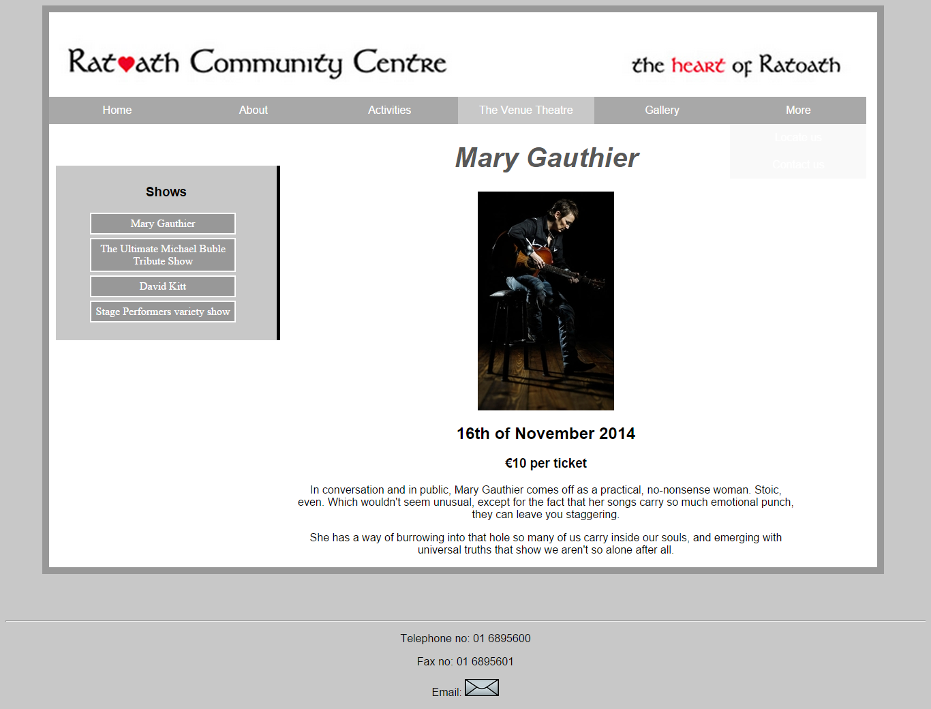

**Gallery page**

The gallery page contains images of the community centre and events that have taken place at the community centre. I used an image rotator to cycle through all the images in the gallery. I added thumbnails off all of the images in a box below the slide show. The user can click on the thumbnails and the image will be display larger in another window. The user can also press “show more” to see more images.

**Default gallery page**

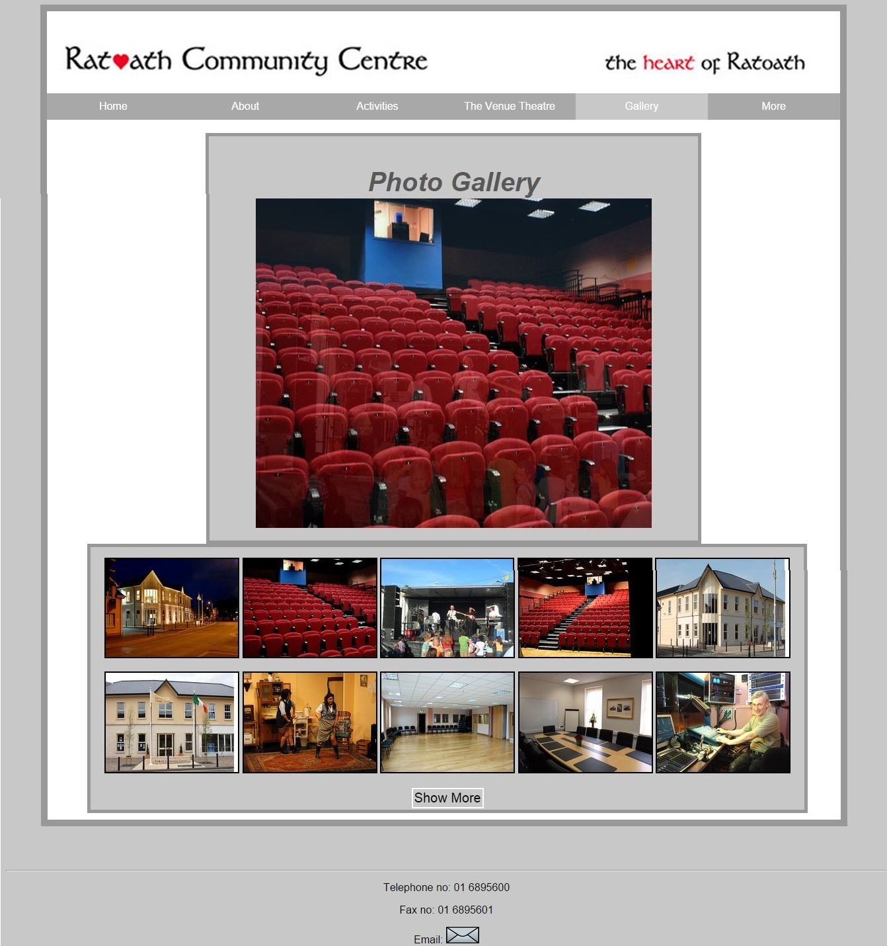

**Gallery page with a thumbnail selected and show more pressed**

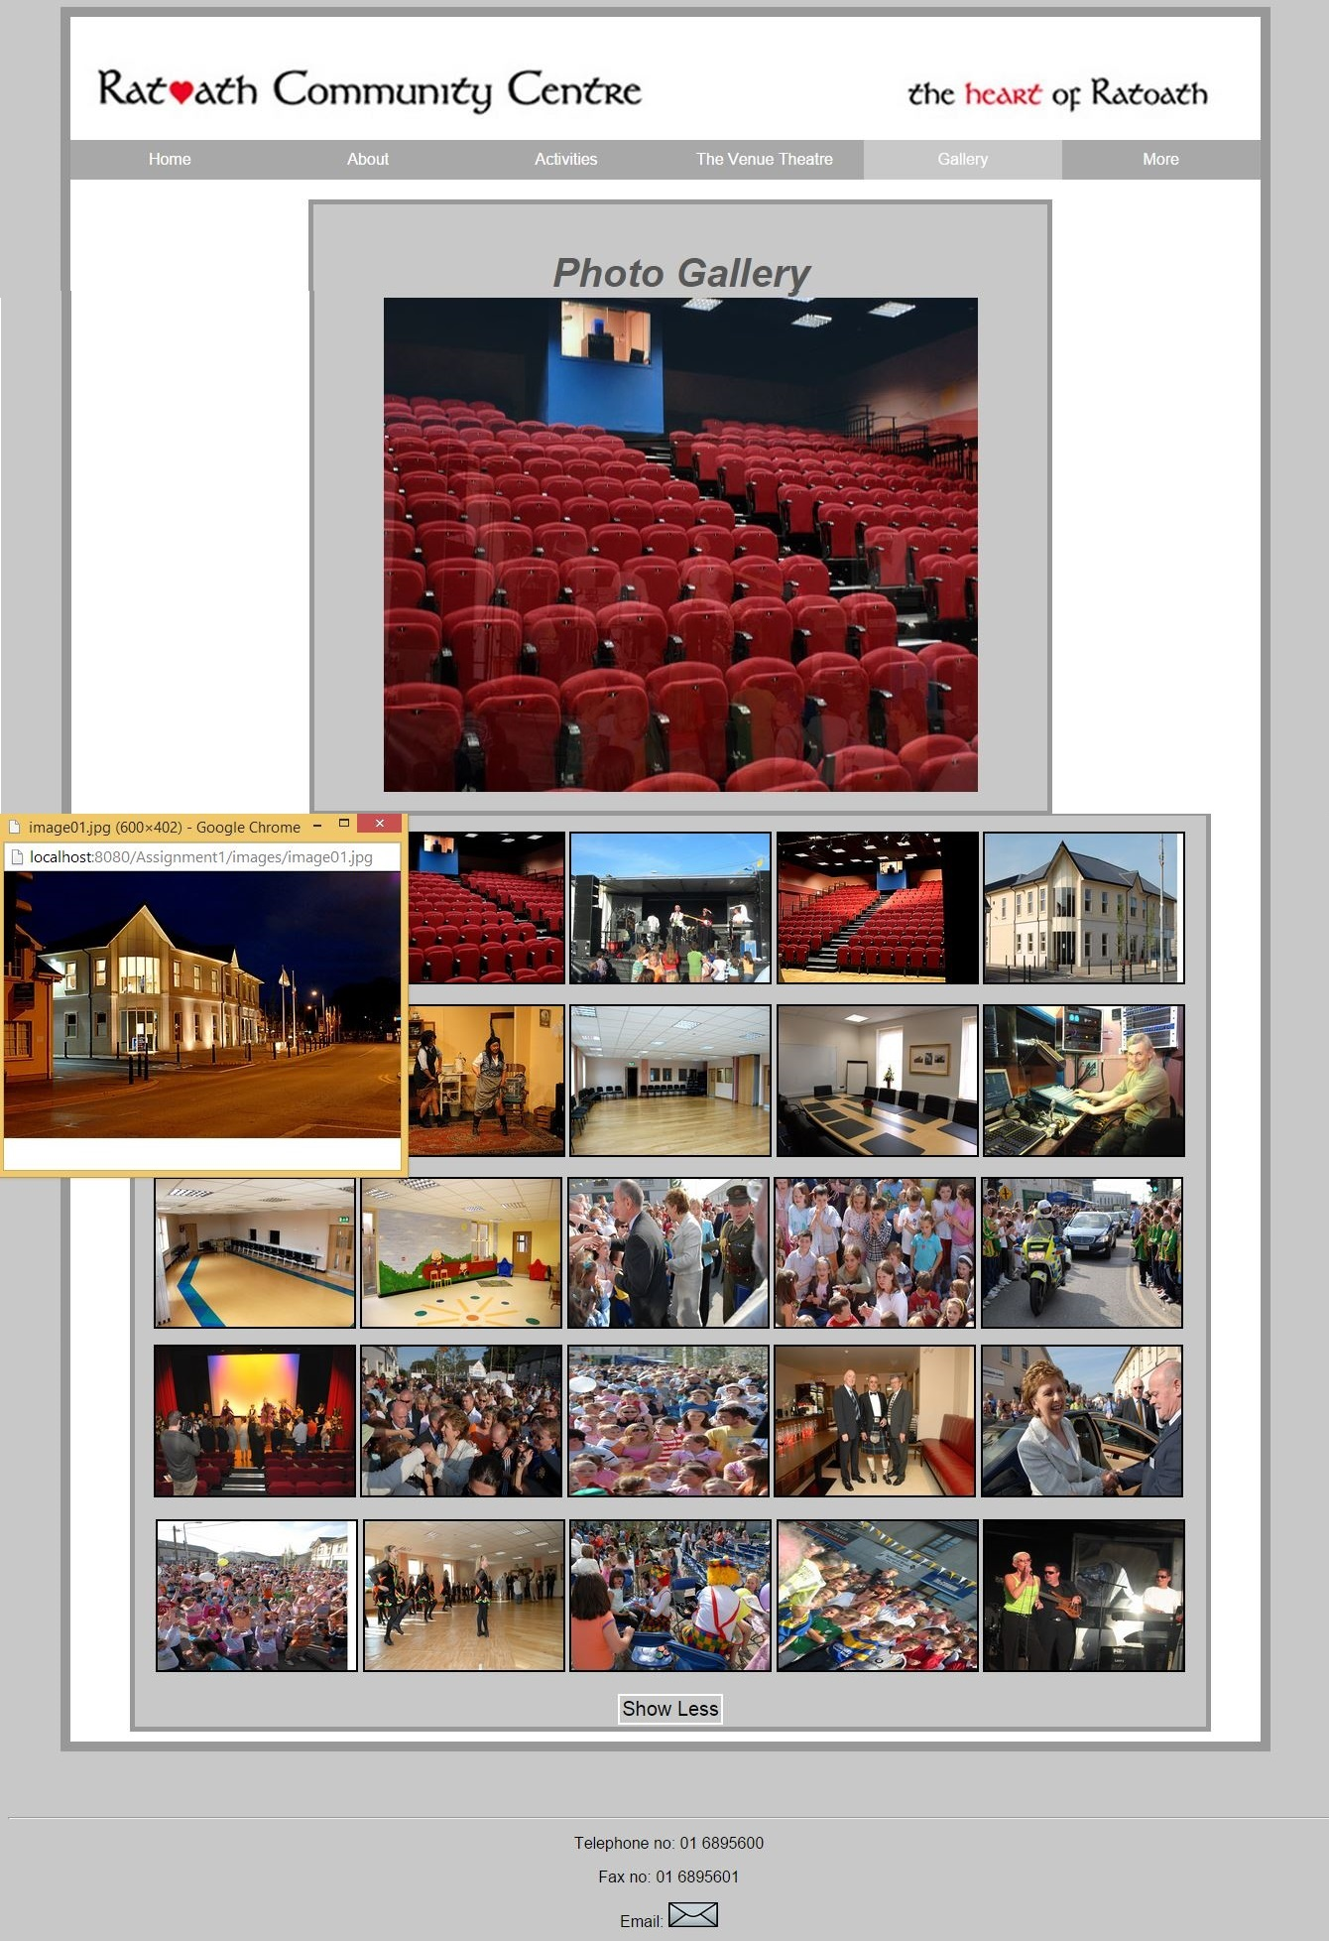

**Locate us page**

The purpose of this page is to help the user to get to the community centre from where ever they are in Ireland. There is a custom icon on the map representing Ratoath Community Centre. When the user hovers over it, it shows the title. The user can enter in their location, and then step by step directions will be displayed on the right hand side of the page. It will even tell the user how long their journey should take. The map will show the path from their location to the centre.

**Default locate us page**

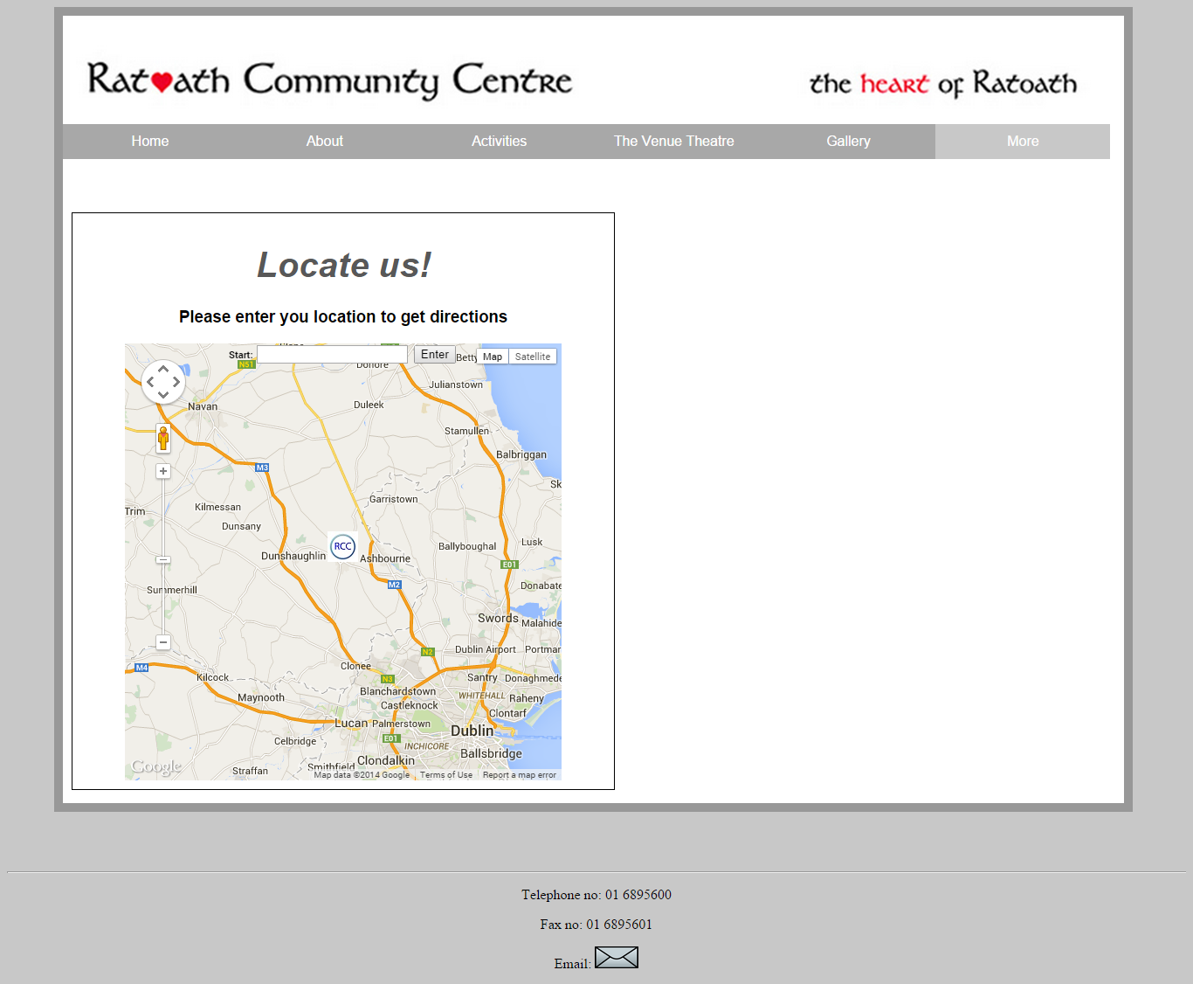

**Locate us page with my address entered**

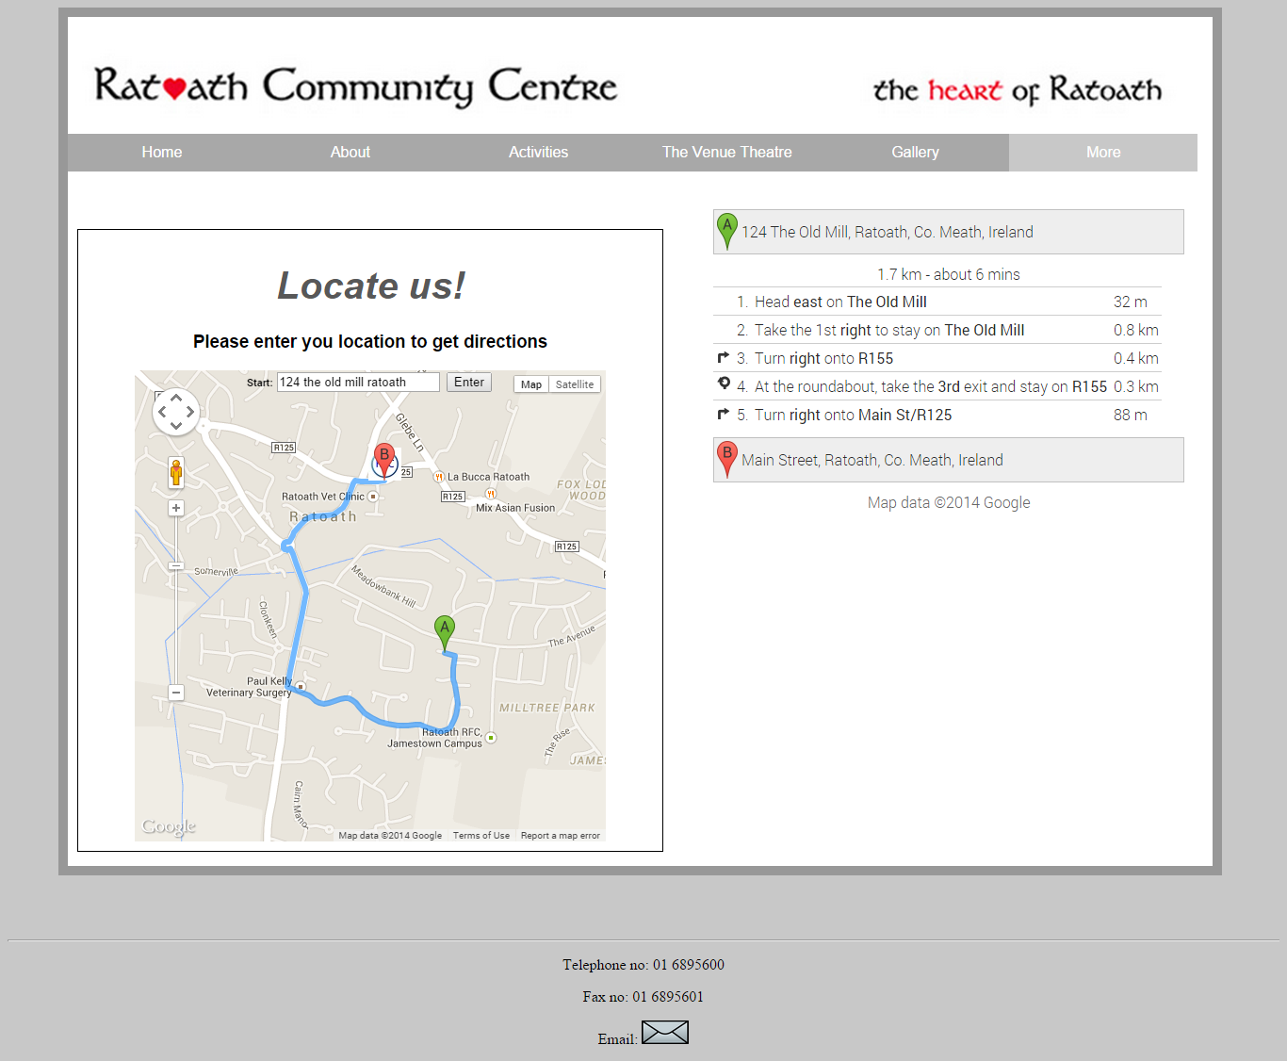

**Contact us page**

This page contains information on how people can contact the community centre. It contains the address, phone number, email address, etc. It also contains all the people who are available to be contacted at the community centre. I used a tabbing system to display this information.

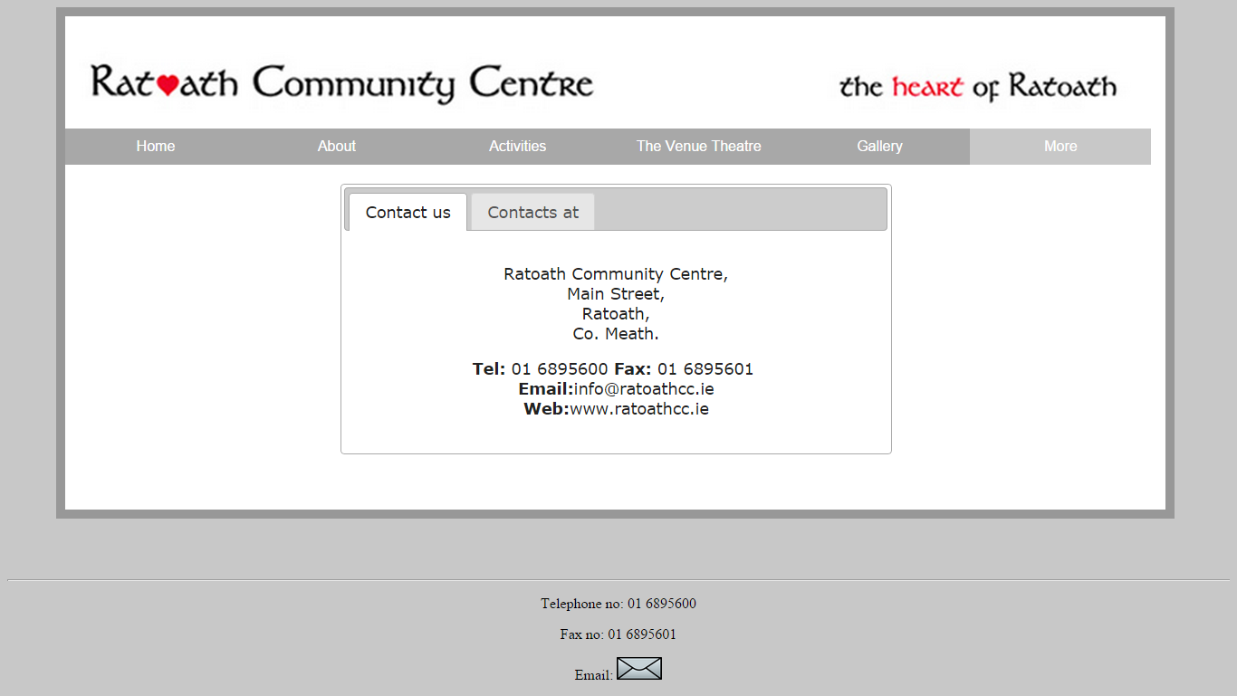

**Conclusion**

I have learnt a lot from doing this project. Most importantly I have learned the importance of planning when it comes to web applications. I have learned how important wire framing is as it gives you something to go off when you start developing a website. I did not plan as much as I believe I should of for this website and I believe it may have had a slight effect on the design of the site. I have learned from this mistake and I will make sure to put more time into planning my next website.

I have also learned a lot about developing web applications. By doing this project it has really helped me to improve on my html, css, jQuery , json, Ajax, and JavaScript skills. I have a learned so many great features that are available through the jQuery UI library. I have also learned a lot about Google maps. I have learned to create my own custom map and give it all the certain features I want.

Overall this project has been a positive experience for me. I made some mistakes when it came to planning and researching. But I believe I will learn from these mistakes. I also gained lots of web application skills which will certainly help me in the future.

**References**

1. [**http://jquery.com/**](http://jquery.com/)
2. [**http://jqueryui.com/**](http://jqueryui.com/)
3. [**http://ratoathcc.ie/**](http://ratoathcc.ie/)
4. [**https://developers.google.com/maps/documentation/javascript/tutorial**](https://developers.google.com/maps/documentation/javascript/tutorial)